Gear Cars: Up and Up, You Go
By: Samuel Hudon
Heritage Regional High School
December 9th, 2024

The Goal:
To make a car that can go up a 30- and 15-degree ramp in the shortest time possible.

Materials:
Copper pipes (some for wheels and gears)
Wheels
2 Motors
Butterfly nuts (for motors)
Rubber Stoppers
Gears (15, 45 and 75 tooth)
Lock Rings
Nylon Sleeves

First Version:
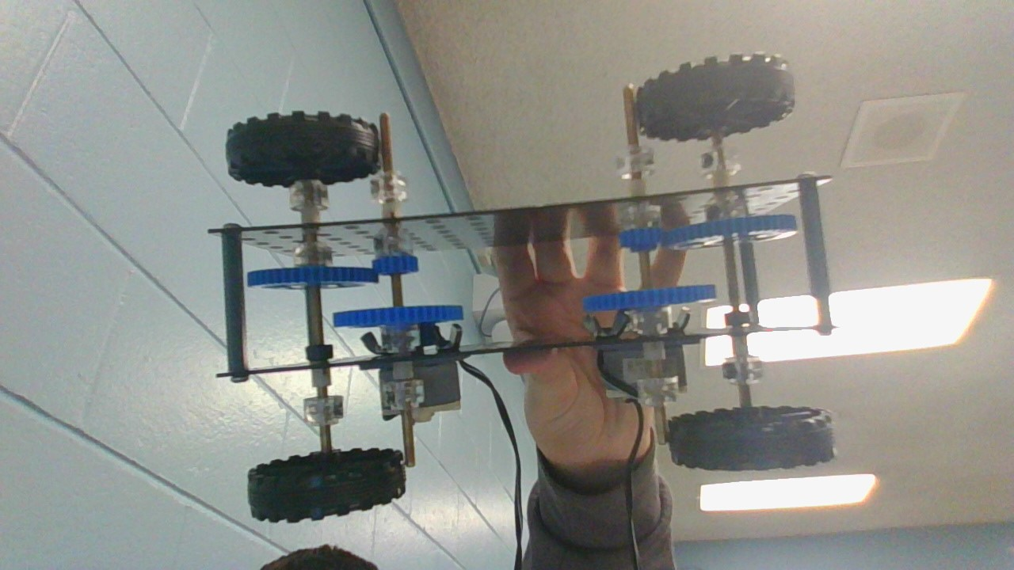
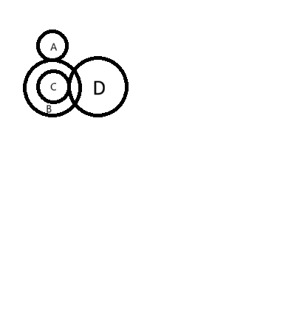
For the first version, I used two motors. Gear A and C are 15-teeth gears whilst B and D being 45-teeth gears. A is the Driver and D is the final Driven. A to B is a ratio of 3/1, C to D is also 3/1. So that makes it a 9/1 ratio for one motor, it’s the same thing on the other side, so it would be a gear ratio of 9/1 for both.

15-degree ramp:
Attempts | Time
1 | 5.51 seconds
2 | 6.34 seconds
3 | 5.74 seconds

30-degree ramp:
Attempts | Time
1 | Failed
2 | Failed
3 | Failed

2nd Version:
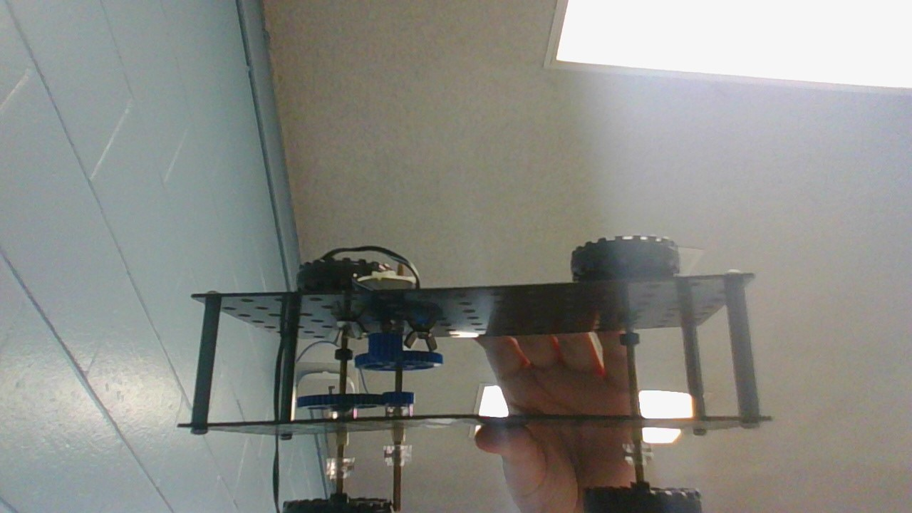
Yes, I know that it is the same thing as the last version, but I removed one of the motors which keeps the gear ratio at 9/1. (only once this time).

15-degree ramp:
Attempts | Time
1 | Failed
2 | Failed
3 | Failed

30-degree ramp:
Attempts | Time
1 | Failed
2 | Failed
3 | Failed

The results show that my car needs 2 motors to successfully go up a ramp.

